Chapter 6, Problem 73.

Show that the circuit in Fig. 6.90 is a noninverting integrator.

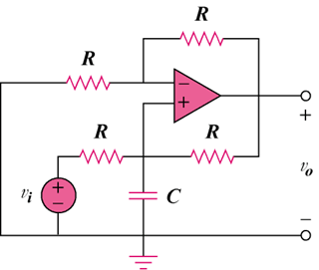

Figure 6.90
For Prob. 6.73.

